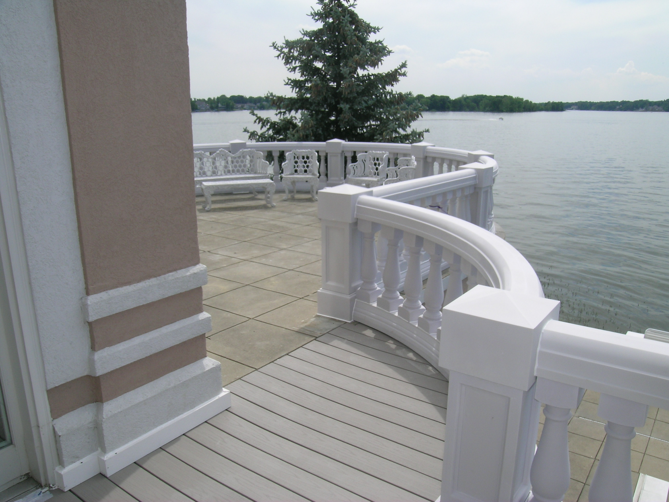
Ultimate Decks
By
Chermark

Custom Decks
Gazebos & Sunrooms
Patio Pavers
Stamped Concrete

Also offering other Specialties:

Roofing & Siding
Basements
Additions
Remodels
Insurance Work
Any Carpentry Needs

Licensed, Insured, Bonded Discount with Flyer
Refer a friend Incentives 317-364-Decks
Call for Free estimate 888-215-8960
E-mail: ron@chermarkllc.com Website: www.chermarkllc.com

